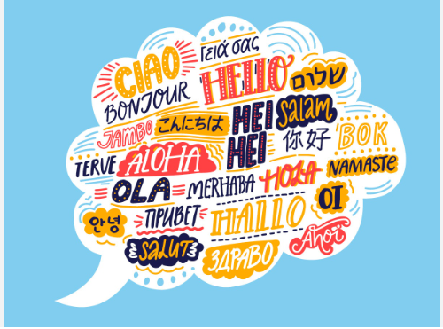

January 2024

Home Languages Day - Friday 22nd March

Dear Parents and Carers

As an international school, we are holding an event to mark the importance of all languages spoken within our community. In school, KS2 learn French in lessons but we also know that some children at home speak another language, celebrate festivals, learn dances and other activities related to different cultures. It is very important to the children and the community that we highlight and celebrate these home languages. It will give all the children a positive experience that allows them to have an insight into other cultures and allows children and adults alike to learn from each other.
On Friday 22nd March, we would like the children to come into school dressed in the colours of the flag that represents their family heritage. So I am planning to come in the colours of the Irish flag as most of my family are Irish. Children are welcome to come into school simply in their flag colours or they can go that extra mile and enter our competition for the most creative flag outfit and winners will receive a prize.
During the day, children will be invited to share words, phrases and facts about cultural events that they celebrate at home related to the country that is linked to their family.
We would love for parents, families and the Silsoe community to be involved in this day. If you speak another language at home, celebrate festivals from another country, we would love your help and involvement in the day or at some point in the week beginning 18th March. We would be grateful if you could fill in the google doc to let us know how you can help us with the planning of this event.
Your Sincerely

Mrs H McCarthy
International School Lead

